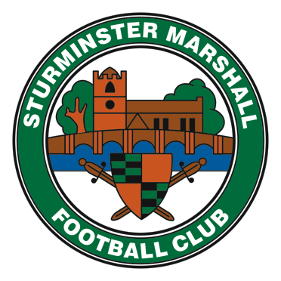Sturminster Marshall Youth Football Club Membership Registration Form 2018/2019
PLEASE COMPLETE THE FORM IN BLOCK CAPITALS ONLY
PLAYERS FULL NAME:...................................................................................................
I (named above) wish to sign for Sturminster Marshall Youth Football Club. I have read and understand the rules and codes of conduct. I Agree to abide by all club rules and codes of conduct.I understand that the £45-00 (£22.50 for Mini Kickers and Children of Committee Members) signing on fee is non refundable and I declare that I have not signed for any other DORSET TEAM for the 2018 / 2019 Season.
Players Signature:..................................................................................................................
Parent Signature:……………………………………………………………………………………

ADDRESS: House number/Name:..........................................Postcode:..................................
Street:............................................................................................Town:...................................
PARENT/CARER NAME:MR/MRS/MISS/DR/Other:.................................................................
PARENT/CARER HOME PHONE: AreaCode:.......................Number:.....................................
PARENT/CARER MOBILE PHONE:.........................................................................................
PARENT EMAIL:......................................................................................................................
PARENT DOB:……………………….

PLAYERS SCHOOL:.................................................................................................................
SCHOOL YEAR FROM SEPT 2018 to 2019:YEAR:..................................................................
PLAYERS DATE OF BIRTH:........../............../..........SMYFCAGE GROUP: UNDER...............ʼS

Medical Details : Please indicate if your Son/Daughter has any medical conditions that we should be aware of, e.g.; Asthma,Eczema,Hay Fever,Regular Nosebleeds,Allergic to Penicillin,Nut Allergies,Epilepsy, Allergic to plasters or latex gloves. IF NONE please state NONEOtherDetails......................................................................................................................................
In the Event that the Parent/Carer cannot be reached, Please give two other emergency contacts

1st Emergency Contact NAME:..............................................................................................
1st Emergency NUMBER:.................................................................................................
2nd Emergency Contact NAME:.............................................................................................
2nd Emergency NUMBER:......................................................................................................

Medical Consent: In the event that my Son/Daughter is injured whilst playing football or traveling to and from football events and I cannot be contacted on the above phone numbers,I hereby give my consent for my child to receive medical attention. Yes / No
S.M.Y.F.C Web Site: www.smyfc.co.uk
I give my consent to allow my Son/Daughter inclusion e.g use of abbreviated name in match reports and picture in team photos on the club website and other social media Yes / No
I acknowledge that the club will be sharing personal details with local leagues and the FA for Affiliation purposes. Players cannot play without doing so Yes/No

Parent/Carer Rules and Regulation Consent I agree that the information listed is correct, and agree for my Son/Daughter to play for Sturminster Marshall Youth Football Club. I & any persons attending with the player agree to be bound by, and observe the club rules/codes of conduct,the FA Respect program, the rules and regulations of the Football Association Ltd, the County Football Association and any rules and regulations for the competitions in which the club enters.
Signature:..............................................Date Form Completed:.........../............./............

Printed Name of person Completing this Form:.................................................................

The League/tournament fees for the forthcoming season are £3-00 per player per match/tournament. These fees are payable each match and tournament. (Teams may collect a variation of this fee to cover Assistant referees)

Any player/carer or supporter that are found to be in breach of the club rules/codes of conducts or players receiving cautions/sent from the field of play may be asked to sit in with our disciplinary committee where further action may be taken.

To participate in training or friendly/league football matches,this form must be returned with payment to the club.Players will not be asked to play if the form and full payment has not been received.

Yellow Training Kit Required
Shirt (Please Circle)

LM SM Y B SB

Shorts

LM SM Y B SB

Socks

7-11 2-6 12-2

